Russ Ronalds Comp Ling

4/4/19 HW5

Part 1

1. The reason that our stub produces so many long sentences is that each time an NP occurs, it has a 50% chance of producing both another NP and a PP, which itself contains another NP, *and* every VP automatically produces yet another NP. So, there should be a 25% chance of S becoming just a Det/Noun/Verb/Det/Noun, and then the other 75% chance of Ss start to have a lot (see appendix 2) of NPs.

2. While the program allows multiple adjectives, it does this rarely because [‘Adj’, ‘Noun’] only has a 1/6 probability of appearing given a ‘Noun’. So two adjectives have a 1/36 probability.

3. In order to address the problems in:

1. I (would) need to increase the probability of NP-> Det/Noun production over NP -> NP/PP;

2. I (would) need to increase the probability of Noun -> Adj/Noun. (Of course now we have another problem of delicious delicious delicious presidents eating every perplexed perplexed pickled sandwich in every president)

4. In addition to increasing Noun ->Adj/Noun, I increased each of the individual nouns as well, so that it doesn’t just get into a loop of producing far too many adjectives. This is sort of just a necessary component of the 2nd change in Question #3.

I also reduced the relative frequency of “Is it true that” questions. While it is our only question form at the moment, it seems too frequent.

I also decreased the relative frequency of “every” as a determiner, since it was overproducing. And decreased the amount of pickling that was going on. Every president was getting pickled too often.

Ten generated sentences:

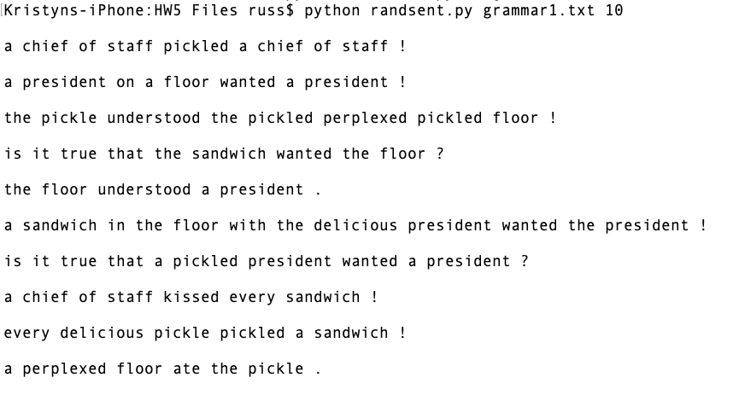

Part 2

1. Add Sally as an NP
2. Add Conjunctions
3. Add sighed + intransitive verbs as VP -> sighed, instead of VP->VP NP (transitives)
4. Add VP -> thought that S
5. Add ROOT-> that S perplexed NP .
6. Add Adj-> very Adj
7. Add NP -> worked on NP

The changes in grammar2.txt are commented above the addition, e.g. # [PART 2, f)]

Ten generated sentences:

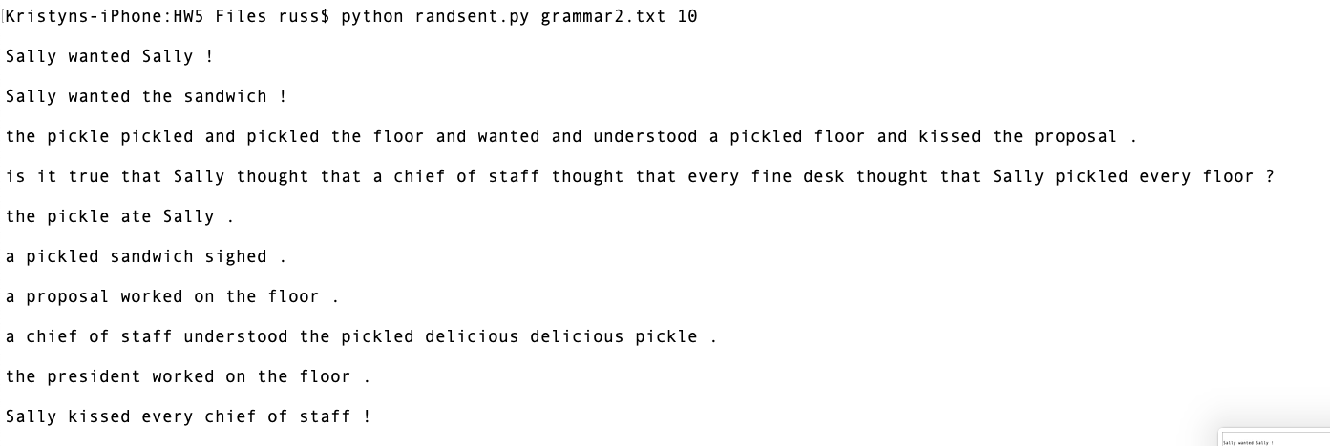

Part 3

Five generated bracketed strings:

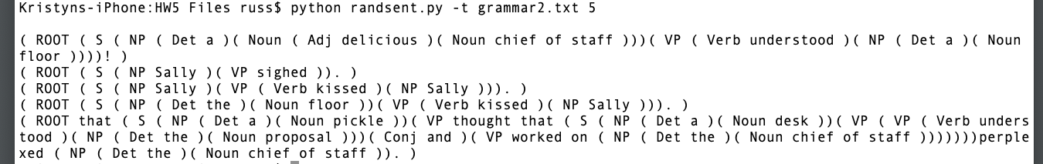

Part 4

5.

(ROOT (S (NP (NP (Det every) (Noun sandwich)) (PP (Prep with) (NP (NP (Det a) (Noun pickle)) (PP (Prep on) (NP (Det the) (Noun floor)))))) (VP (Verb wanted) (NP (Det a) (Noun president)))) .)

6. Well, the only reason to eliminate the ambiguity is to clear up whether the pickle is on the floor or the sandwich is on the floor. Each sandwich that has a pickle-on-the-floor wants a president, or each sandwich on the floor, which also has a pickle, wants a president.

Appendix 1

A pickle kissed the pickle under a sandwich on a chief of staff with a chief of staff on a president under a floor in the sandwich with a president in a sandwich in the perplexed sandwich with every perplexed chief of staff under every president with every chief of staff in a president in a chief of staff under every perplexed sandwich in the sandwich with every floor with a fine chief of staff in every pickle in a president on the floor with a chief of staff in every sandwich with every floor in a pickle with the floor on every pickle on every floor with the floor on a chief of staff with a sandwich under the chief of staff on a pickle in every floor with every president in the president under a pickle on every chief of staff under a chief of staff under a floor on every delicious sandwich with a delicious floor in a president on every sandwich on a president under the president with a sandwich in a president on every delicious sandwich in every fine floor on every pickle on the fine pickle in every floor in every president with the pickle on the floor on every floor on the floor with a sandwich under every floor with the president with the chief of staff under a pickled delicious president in every pickled sandwich in the sandwich with a floor under the pickled pickled chief of staff on a chief of staff with the pickle on the chief of staff with every floor under every chief of staff with every president in every chief of staff under every sandwich in a sandwich with every floor on the delicious pickle with a president under a sandwich in the president on a sandwich in every president under a floor in the chief of staff in the chief of staff in the pickle with a perplexed pickle with a sandwich in a chief of staff in every pickle on the president under every pickle in the sandwich under every floor on a floor on the floor under a pickled floor under a chief of staff in every sandwich under a sandwich with a chief of staff with a sandwich on the president on the president on a fine chief of staff on a fine pickled pickle in the chief of staff with the delicious pickle in the pickled sandwich on the floor in the floor with a president with the president in every pickle with every president in a floor with the president with the president under the delicious pickle in the sandwich on every sandwich in the president with the pickled pickle under the floor under a sandwich on the floor in the sandwich on the chief of staff under the floor with the sandwich in a pickle under a president under the chief of staff with the pickle with every pickle with every fine chief of staff on every floor in every sandwich under every chief of staff under a president on a chief of staff under the sandwich with the sandwich on the president on a president with the sandwich in the chief of staff with every pickle on the pickle in the pickled fine president under the floor with a pickled floor with the floor with a president under a sandwich on a chief of staff in the floor under the president in every floor with the president in the chief of staff under a fine fine pickle in a chief of staff with every president with a chief of staff in every sandwich in every pickle with the floor with the sandwich with every perplexed president in a chief of staff on every sandwich with every fine floor on a chief of staff in every pickle in the pickle in every pickle on every chief of staff with a pickle with the president with the chief of staff with every fine floor on a floor on a perplexed pickled floor on a pickle with a pickled floor on every president in every chief of staff with the pickle with every floor in the president with the sandwich on every floor in every chief of staff in the president in the chief of staff with every floor under a sandwich on a floor with a pickle with the floor in a delicious chief of staff with every pickle on every sandwich in every pickle on the delicious floor on the sandwich under the president in the sandwich under a sandwich on a president under a president in the delicious floor in every perplexed delicious sandwich with every fine pickle under a pickle on a pickle with a president in the floor with the pickle under the president with every pickled sandwich under a president in every president with the sandwich in a floor under the chief of staff under every sandwich in a chief of staff on every chief of staff with the chief of staff on a pickle under a president in a sandwich with a chief of staff with the chief of staff with every president on the perplexed chief of staff with every chief of staff in a president on the president with a chief of staff under the pickle under every floor in every chief of staff on the president with every floor under the chief of staff with a pickle on a pickle on every pickle under every president in the floor under every sandwich on every sandwich with every pickle in the chief of staff with every chief of staff in every sandwich under the perplexed floor in every chief of staff on the chief of staff with the pickle on every sandwich with every delicious floor in every sandwich under every chief of staff in a sandwich on a pickle on every pickle under every sandwich with every president on a chief of staff in the chief of staff in a floor under the pickle with a pickle in the perplexed floor on a pickled pickle with a sandwich on the chief of staff on the president in every pickle under a pickled floor under the chief of staff under a pickled floor in a pickled president with the pickle under the sandwich under the pickled perplexed sandwich with every sandwich in every sandwich under the chief of staff in the floor in a president in a sandwich with a delicious delicious perplexed pickle in every chief of staff on a fine president under every president on a sandwich under every floor with the fine president in the delicious pickle on every perplexed delicious sandwich on every floor in the pickled chief of staff under a sandwich in the chief of staff on every chief of staff on every chief of staff under a president on a president on every chief of staff under a chief of staff in every pickle under a sandwich on every president on the chief of staff under the floor in a chief of staff with a sandwich with every president on the sandwich in a president in the floor under every pickle in a chief of staff on the president on a pickle in the sandwich under the chief of staff under every floor in the chief of staff under the delicious pickle with a pickle under a floor on the pickled floor with every fine pickle under a floor under the pickle under the chief of staff on the perplexed chief of staff under a chief of staff in every pickled delicious delicious sandwich in a chief of staff on every fine chief of staff in the perplexed pickle on the sandwich with every pickle with every perplexed pickle with the pickle under a floor under a floor with the delicious sandwich in the sandwich under every chief of staff on the sandwich under the chief of staff with a chief of staff on the president in the pickle with every sandwich with every pickle in a president on every fine pickle with a pickle under a sandwich on every pickle on every fine president on the pickle on a president in a sandwich on every chief of staff on a perplexed floor under a president with a floor on the sandwich with a pickle in every chief of staff under every floor on a fine delicious pickle under a delicious chief of staff in every pickle on a fine pickle on the president on the president under every sandwich under the pickled president with the floor in the pickled pickle in every sandwich in every sandwich in the delicious pickle in the chief of staff in a delicious president with a floor under a sandwich under a pickled president on a floor on a chief of staff on a president under the president on every floor on the floor with every chief of staff under the fine floor on every president under a sandwich on the chief of staff under the pickle on a floor in the floor in the president with a floor with every perplexed sandwich on a floor under every sandwich with every pickle with a floor under a chief of staff in every floor in the chief of staff under every sandwich with a president under every president under every floor on the perplexed delicious president on a sandwich under every president in a sandwich with a chief of staff in every sandwich with every chief of staff under every delicious sandwich under the chief of staff in every president under every sandwich under every floor in a delicious president under a chief of staff in a floor in every pickle in the president in the pickle under the sandwich on a chief of staff with the delicious sandwich under a fine president with a pickle in the sandwich in the floor under the president with every president on a floor with a perplexed delicious pickled president on every sandwich with the president under the president in every perplexed president on a chief of staff in every delicious sandwich under the sandwich under every pickle on the perplexed chief of staff on the floor in every sandwich under the sandwich on a pickle under a pickle in every floor on every floor with a pickle under every chief of staff in every president with a chief of staff with a pickle on every president under a sandwich with every sandwich on the chief of staff with the president under a sandwich under a pickle with every fine president with a pickle on every floor in every floor in the pickle in a chief of staff with the sandwich under a sandwich with the chief of staff on every chief of staff under the president with the pickle on the pickle under every chief of staff with a perplexed delicious perplexed sandwich under every president with a fine chief of staff with every perplexed chief of staff under a chief of staff under the perplexed chief of staff on a chief of staff with the delicious chief of staff on a delicious perplexed pickle with the chief of staff with a pickled sandwich under a perplexed floor on the delicious floor with a pickled floor under the perplexed chief of staff in a president with the floor under the pickle on the president on a sandwich on every perplexed pickled sandwich with the president in every president on the president in every pickle in every fine floor on the president under a sandwich on every president on the chief of staff in a delicious president under every floor under every floor with a sandwich with a chief of staff with the fine president with every president under a pickle in the floor with the fine floor with the chief of staff in the floor with the pickle with the fine president under a pickle on the pickle on the perplexed sandwich with the chief of staff on the pickled chief of staff on every president under a fine pickle under every delicious floor on a pickle on the floor under every pickle under the pickle on a floor under every floor under the delicious floor on the perplexed president on every chief of staff on the sandwich under every pickled president with every floor on the pickled perplexed chief of staff on a sandwich with a fine delicious chief of staff under the sandwich in a delicious pickle with the president with the president with the perplexed floor in every fine pickle under a fine sandwich with the chief of staff on every perplexed president under every president on every president on every president on every sandwich with every pickle in every floor on every president on the sandwich under a president in the sandwich in the pickle with a pickled sandwich on every sandwich with every pickle under the pickled president under every chief of staff with every pickle under the president in a floor in the president under every president on every sandwich under every floor under a president with every chief of staff with the chief of staff in a perplexed floor with every sandwich under every chief of staff under the pickle under the delicious delicious floor under the floor in the delicious pickle with a sandwich on every chief of staff under the sandwich under every pickle in the chief of staff with the sandwich in every president on the chief of staff in every president with every president under a sandwich under every sandwich in the floor with every president with a chief of staff on a chief of staff under every sandwich on every floor on the floor on a pickle on the pickle under every chief of staff under every perplexed pickle with the chief of staff in the chief of staff in a floor with the pickled chief of staff on every pickle with every chief of staff under a pickle in every chief of staff with the floor under the president in every president on every president with a sandwich in the sandwich with a pickle with a floor with a pickled president in every sandwich under the president on a pickle in the pickle with every sandwich in a delicious chief of staff under a president on the floor with the president under a perplexed perplexed chief of staff on every chief of staff on the chief of staff on the floor with the perplexed sandwich with a pickled sandwich under a pickle on a chief of staff on every floor under the delicious chief of staff on every president on a chief of staff under the president on the president under a president with a fine pickle under the president under every president with every floor with the president with every fine floor on every perplexed pickle on the floor with the floor in a delicious pickle on every president with the chief of staff on a delicious sandwich in every pickle in every chief of staff on the floor under every delicious president with every president on the sandwich under every chief of staff on every floor with the floor in every fine sandwich on a pickle under every president on the president in every chief of staff in a floor in a sandwich under the sandwich in every president in the president with a president with the president with the chief of staff under every pickle with the president on the pickle with the pickled president in a president under a president in the president under every chief of staff with a floor in every pickle with a president on a floor with a fine president under a floor with the pickle with a president on a sandwich on the sandwich with a perplexed chief of staff on the pickle with the sandwich on the president in the pickle under every president with every pickle on a floor with the pickle under a floor on a sandwich with the floor under the pickle with the sandwich under the perplexed floor on the floor on a pickle with a delicious pickle in every chief of staff with a floor under the floor with the president under every chief of staff in every pickle with the fine president on the perplexed chief of staff with a floor in the delicious floor in every delicious sandwich in the floor with every floor under the pickle under the floor in every pickle under a chief of staff in the sandwich in the delicious sandwich on the pickle with a pickle in the floor on a sandwich under the sandwich on the sandwich in every floor under a pickle with every pickled chief of staff in a chief of staff on a sandwich with a sandwich under every president with every president with the floor with every president in a floor on the pickle under every chief of staff under a floor in every fine sandwich in the president with the floor under every floor on every chief of staff under a president under every sandwich on every sandwich under every chief of staff under the president in a perplexed delicious sandwich on the floor under every pickled sandwich under a floor on the fine sandwich on a delicious sandwich with a floor on a chief of staff under a sandwich in a floor on a sandwich with a sandwich under a president under the president on the sandwich in every president on every pickle in a floor in a pickle under a sandwich under every president with every president on every sandwich on every sandwich in a floor under the chief of staff in the pickle with a floor in a pickle under every perplexed pickle on the floor on every delicious fine president in the chief of staff with a sandwich under every president on every chief of staff in a fine sandwich in a floor in every sandwich with every fine sandwich in a floor in a pickle in a pickle with every sandwich in every floor under every sandwich under the sandwich on the pickled president with the chief of staff in the chief of staff on a floor under the chief of staff with every sandwich under the pickle on a chief of staff under every president on the floor on a chief of staff with every pickle under every president in every delicious sandwich in every sandwich in every pickle on the pickle with every chief of staff under a pickle in a floor with the president under a sandwich on every floor on every sandwich with the pickle on every president with every floor in the president under the president on the president with a sandwich under the chief of staff on the chief of staff with a pickle with every fine pickled president under a president in every chief of staff in the pickle on every chief of staff in a chief of staff under every delicious chief of staff with every fine floor under every pickle on every perplexed floor with every pickle under a fine floor with a perplexed chief of staff with the delicious chief of staff under the pickle with a fine pickle in the floor in the president in a chief of staff with the delicious sandwich with the sandwich in the fine floor with a sandwich on a chief of staff in every floor in the perplexed chief of staff with every chief of staff on a pickle on the president in a perplexed delicious pickle with every perplexed chief of staff with the floor on the chief of staff on the delicious pickle on a president with a pickled fine pickle on a president under the pickle with a president with the president with every pickle with every delicious perplexed pickle with the chief of staff on the chief of staff with a pickled president on a floor under the floor under every pickled floor with a president under a pickle under a floor in a president with a president on the pickled perplexed president in the perplexed chief of staff in a sandwich with a president under the floor on every delicious sandwich on every floor under the floor in the president under a delicious chief of staff on every president in a floor on the sandwich with a floor on every pickle under every floor in every chief of staff under every sandwich in the chief of staff on the sandwich in every fine president on every floor on a floor under a delicious president with a chief of staff with the perplexed chief of staff with every president in every delicious pickle in the floor under a chief of staff in the chief of staff with the sandwich in every perplexed chief of staff with a floor on the floor under every pickle in the chief of staff with every chief of staff with a chief of staff under every chief of staff with a floor with every sandwich in every president under every perplexed perplexed president with a sandwich under the sandwich in every chief of staff under every chief of staff on the perplexed floor under a floor under a pickled floor with a sandwich with the pickle with the president under every chief of staff under the floor on a chief of staff in a chief of staff in a pickle with the chief of staff under the perplexed pickled chief of staff in every sandwich under the pickle in every sandwich with a floor in every chief of staff in a chief of staff under a sandwich in the floor with the delicious floor in the pickle in every pickle with the chief of staff with a president in a floor under the floor in the sandwich with every president with every sandwich in the floor with every sandwich in every sandwich under the chief of staff with a floor on the president with every perplexed president in the perplexed president with every delicious pickle under every sandwich on a pickle in the pickle with a floor with a pickle in every pickle on every delicious sandwich with the delicious pickled president under every floor on every pickle on every president with the chief of staff with a pickle under the floor under a floor on a sandwich in a perplexed perplexed fine president on every pickle under a delicious pickle on the floor under every president with every pickle on every chief of staff with a chief of staff on a pickle with every sandwich with every perplexed floor under a pickle with a chief of staff with a pickle on a president under the fine president on a delicious floor with a chief of staff on every sandwich in a president with the pickle in every pickled pickled perplexed floor in the floor in every president under the floor under the president under every floor under the pickled chief of staff with every president on every pickle under every chief of staff with every pickled sandwich in the sandwich on every floor on a pickle in every president in a pickle on every president with every pickle under a president in a sandwich in the perplexed president in the sandwich under every president with the chief of staff under a floor under every president with every president in every floor in every delicious pickle under the president under every floor under the pickled sandwich on a president in every sandwich under a floor on a sandwich with every sandwich with the floor in the president under every chief of staff with every president under every delicious sandwich under every floor in the sandwich with every sandwich in the perplexed pickle under the sandwich in the president under every pickle with the president in a chief of staff with every sandwich under the sandwich on a floor under a sandwich in a floor on every floor with a sandwich in every pickle in the president in a floor on every perplexed chief of staff in a floor with the sandwich in a floor on the pickle under a sandwich on a floor under the floor on the floor on a chief of staff with the president on a chief of staff on a perplexed floor under every chief of staff in every floor in the delicious president in a president in every president in every floor in the president in every president under the chief of staff under the president in a pickle on a chief of staff on a president on the perplexed president in the pickle under a floor with a fine chief of staff with a pickle in the fine floor in the delicious floor under the pickle in every president under the floor with every perplexed chief of staff with every sandwich in every sandwich under a president under every chief of staff on the floor on the pickle with the president under a pickle under the chief of staff with the floor under the floor with a sandwich under a sandwich under every pickle in every pickle in a sandwich in every floor with a chief of staff in a president with the perplexed chief of staff with a sandwich with a pickle on the floor under a pickle with the pickled president in the floor in every sandwich in a floor under every chief of staff under every delicious floor in the president with every president in a chief of staff under the fine delicious pickle in every chief of staff under every pickle under a fine chief of staff on the fine pickled floor in a chief of staff in every pickle in a sandwich with the sandwich.

Appendix 2 (presumably caused by genNonTerminal trying to recur/recurse too many times inside of itself…)

